A4016-Asia-China-Shang-Gong-Argali-Mountain Sheep-Bronze-1766-1122 BCE

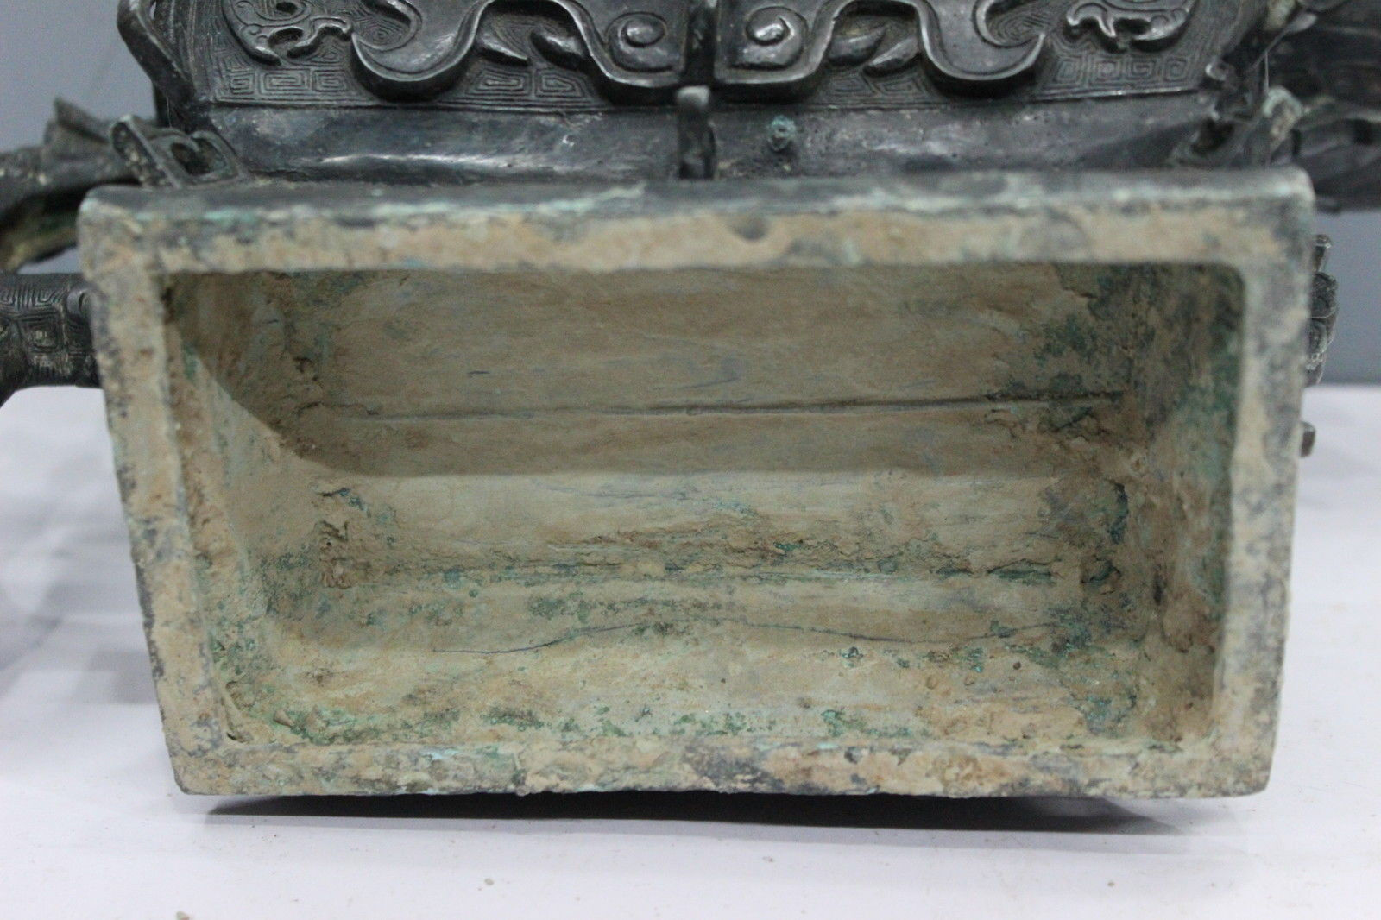 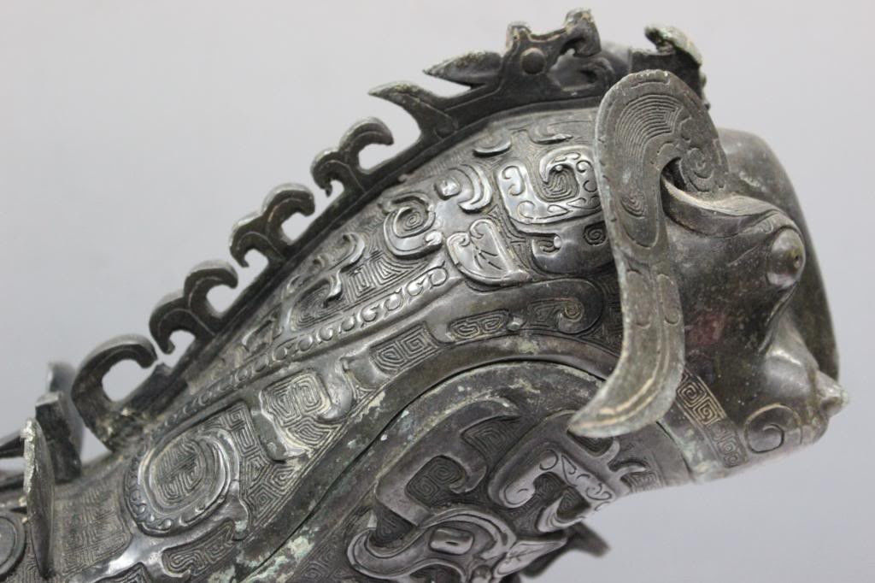 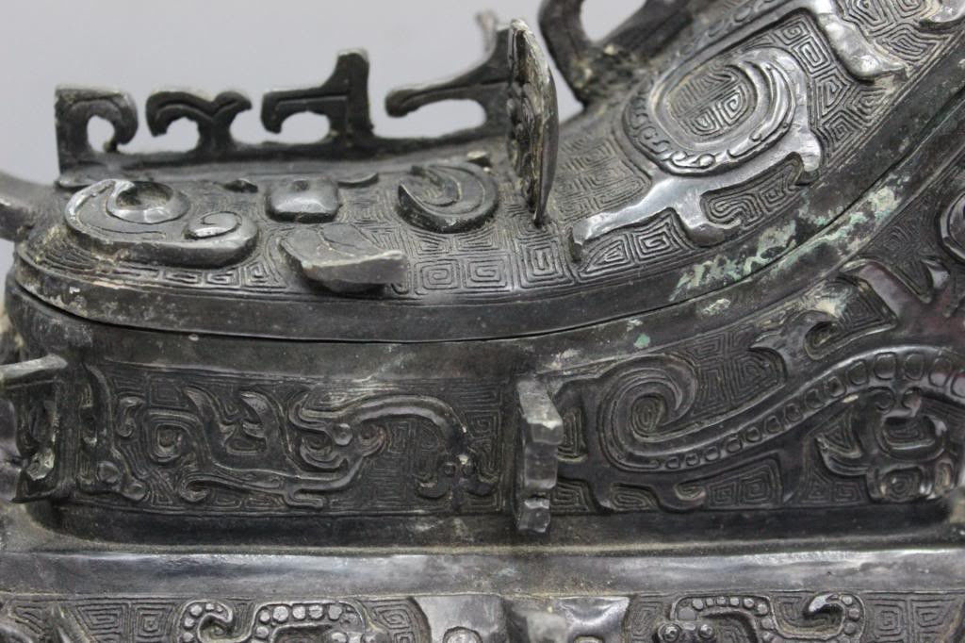 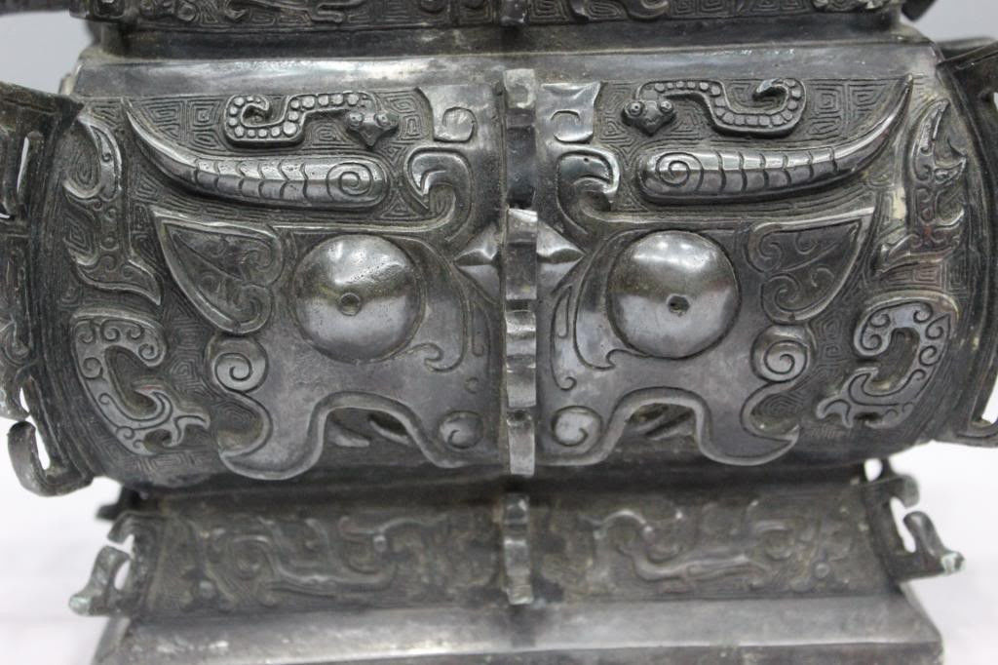 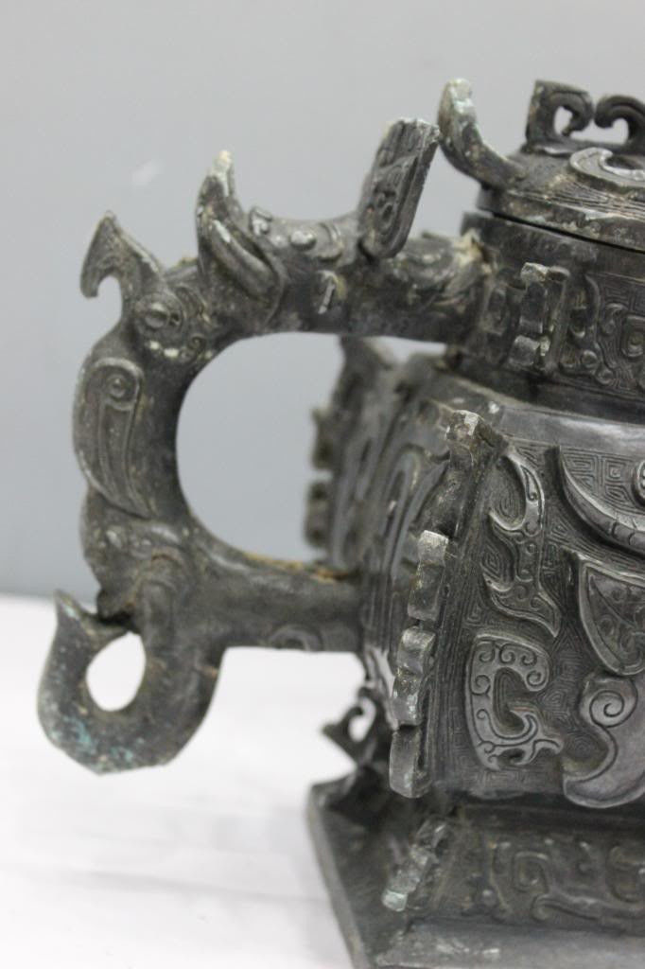 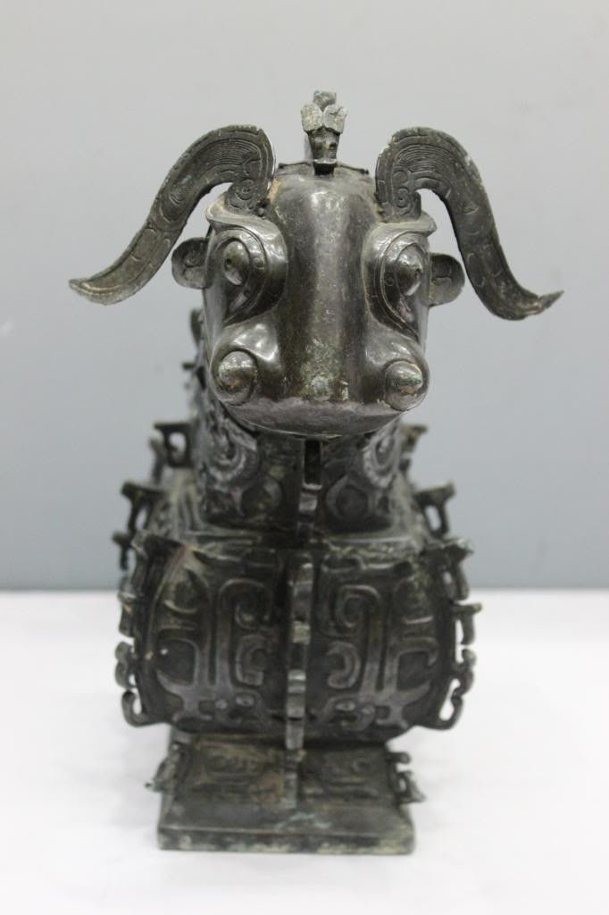 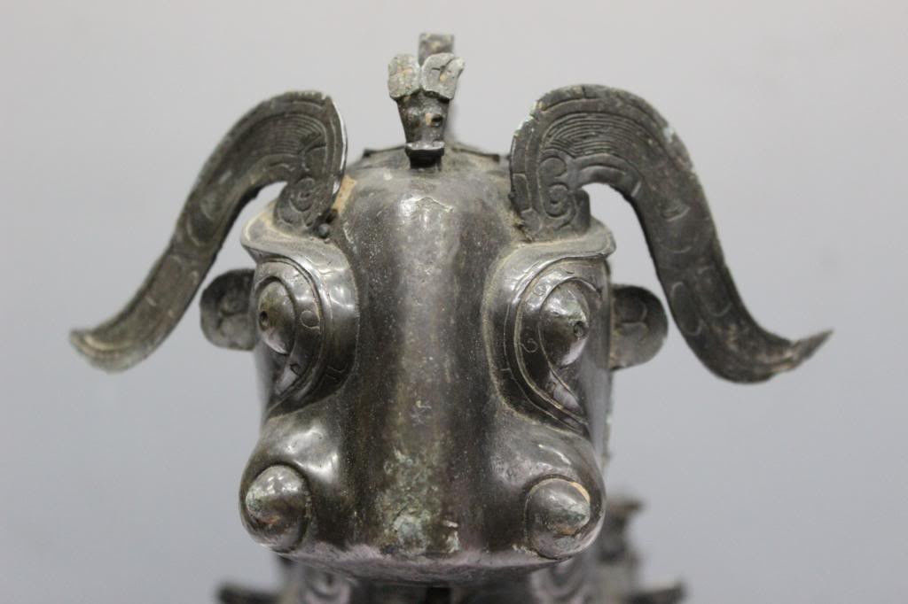

Fig. 1. Shang-Gong-Argali-Mountain Sheep-Bronze-1766-1122 BCE

Fig. 2. Shang-Gong-Argali-Mountain Sheep with a Muntjak behind.

**Case** no.: 5

**Accession Number**:

**Formal Label**: Shang-Gong-Argali-Mountain Sheep-Bronze-1766-1122 BCE

**Display Description:**

This kong 觥(wg kung1) is a ritual wine pitcher in the shape of an argali or mountain sheep dating to the Bronze Age of China. It also is decorated with motifs of various animals, both real and imaginary.

The argali was probably chosen as the animal model for this vessel because it is the largest of wild sheep. The argali are a species (4 ft high at the shoulder) that inhabits areas with elevations of 300 to 5,800 m (980 to 19,000 ft) – often inaccessible mountainous retreats, suggestive of the places that shamans would resort to in quest of a communion with the heavenly spirits. The argali roams the Central Asian Highlands from central Kazakhstan in the west to the Shansi Province in China in the east and from the Altai Mountains in the north to the Tibetan Plateau and the Himalayas in the south. Throughout this region the argali is viewed as a species that communicates with the numinous on the lofty peaks it roams.

**LC Classification:** [NK7983](https://catalog.princeton.edu/cgi-bin/Pwebrecon.cgi?v1=127&ti=101,127&Search_Arg=shang bronzes&Search_Code=GKEY^&CNT=50&PID=pKVneWLtQXoVqZpf1GkbO3sALpiha&SEQ=20180113121113&SID=1)

Date or Time Horizon: **1766-1122 BCE**

Geographical Area:

**Map:**

**GPS coordinates:**

Cultural Affiliation:

Medium: bronze

Dimensions:

Weight:

Condition:

Provenance:

**Discussion:**

**References:**

References: Allan, Sarah. 1991. The shape of the turtle: myth, art, and cosmos in early China, SUNY series in Chinese philosophy and culture, Schenectady: SUNY Press.

